**Introduction**

This project that is assigned to us is with the purpose of design and development of a Course Management Software System using an Object–Oriented Development Approach for Woodlands University College (WUC).

Various techniques that we will use to find and solve the problems of the current course management system are included in this report. We will be interacting with the client on a regular basis and making adjustments to the system accordingly. First of all, elicitation activities will be conducted which will help us find out the main problem domains, our objectives and the projects requirements. Entire documentation of this whole project such as requirement engineering, system analysis and design etc. will be included in this report.

**1.1 Project Background**

Currently, the Woodlands University College is using a clerical system for the management of their courses. Due to it being paper based, they are facing various problems and hence they have asked us to shift this clerical-based system into a digital course management system.

For this, we have been provided with a requirement document containing the most essential functionality that we have to include in this system. We will be doing an elicitation interview to know how the previous system was running and to further clear any possible doubts. Our first priority will be to find out the major problem domains and then come up with the solutions to those problems. We will be proposing the solutions to the client first before applying any of them into practice because client satisfaction is very necessary.

After the client is satisfied with the proposed solutions, the implementation process will start. Creation of Database, login portal, various functionalities deemed necessary will start and we will keep updating the client on the progress of the project.

At last, the final project/product will hopefully meet the client’s expectation and it will have overcome all the flaws of the clerical course management system.

**1.2 Project Aims and Objectives**

The main focus of this group assignment is to make us more confident about our coding skill, whether it is frontend or backend, our database skill and our overall teamwork.

The main Objectives of this project can be set as:

* Find out the existing problem domains by carrying out the elicitation activities.
* Properly note down those problem domains.
* Formulate the solutions for the problem domains with regular meetings with the client.
* Proper planning done for effectively developing the solution set.
* Design the Wireframes and mock-up of all the necessary functionalities for the software system.
* Discussing the final draft with the client.
* Development process starts after the client’s satisfaction with the plan.
* After the development of the system, testing and evaluation starts.
* Results of the testing are then shown to the client to confirm their satisfaction.
* After the client is satisfied with the system, the thoroughly documented report and the software system is then presented to the client.

**1.3 Project Development Methodology**

Agile scrum is the project development methodology that we are going to be using. It is a framework which assists teams to work together. It is a project management system which is sprint based. It allows high efficiency for work that is project-based.

In this methodology, projects are broken down into smaller chunks which are called “sprints” and they have a time period of 2-4 weeks. The most important features are developed first and other features are slowly added in with each sprint. In scrum methodology, several reiterations of the product are delivered to the client to ensure that the final product is of the highest possible quality in the least time period.

There is also a leader that leads the team, known as the scrum master. Their job is to guide the team to follow the guidelines and the methodology process. They are also in charge of making sure the deadlines are being met.

The product owner is the client’s and stakeholder’s representative who use the software. Their main focus is the business part.

And then there is the team. They are a group of professionals who carry out the stories.

First, the sprint is planned with a definite goal/feature to achieve, time frame to complete and how it will be done. Then daily scrum is done where the progress is evaluated and plan for the next 24 hours is formulated. If there are any problems, scrum master is to solve it. Then the sprint is reviewed. And at last, the team does the sprint retrospective where they note down the good and the bad in order for the next sprint to be better and more efficient.

Following is a figure to illustrate the working process of Agile scrum methodology:

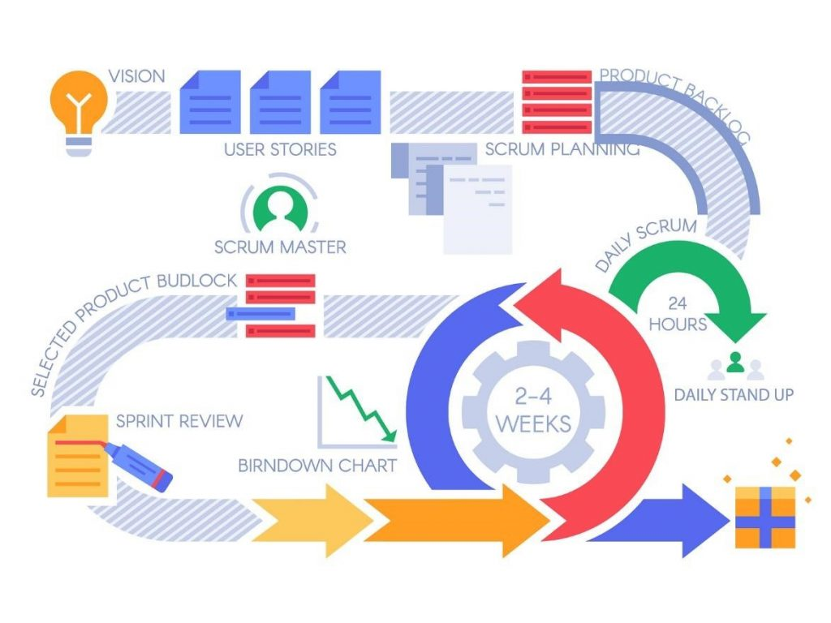

Some of the advantages of using Scrum methodology are as follows:

* The scalability is very easy.
* Client’s expectations can be easily met.
* Change in customer’s or market’s requirements can be met comfortably.
* Most important features of a project can be made and shown to the client first.
* When using this methodology, time for the completion of the project can be predicted timely.
* By carrying out the most important functionalities/features first means that there is less chances of messing up.

**Requirement Engineering**

The process of identifying, preserving and recording requirements in the cycle of software engineering is known as requirement engineering. This is the section where various elicitation activities and requirement specifications are sketched to better understand the client’s desire, need etc. and solutions for the problem domains.

**Elicitation activities**

This is the section that will contain the interview session with the clients. This is done in order to obtain the full description about the course management and the problem domains which are not included in the documents provided to us.

**Interview Plans**

Questions were prepared by our team in order to ask the course leader, senior administrator, lecturer and a student. The questions were prepared in such a way that any confusion that we may have is cleared and to find out more details about the project regarding the client constraints, functionalities etc. that were not included in the documents provided to us.

The findings from the interview are included in the interview finding section. And following are the questions prepared by our team:

**Interview questions for Dr. Simon White:**

**Motivational:**

* What is/are the main reason/s for you to shift from a clerical system to a computerized system?

**Business Models:**

* Before approaching us, did you think of or applied any other alternative solutions for proper management of your courses?
* Can you please provide us with the course details for each student?
* If any student fails to pass module, how would you keep records of those students on clerical system?
* What is the total budget allocated for this project?

**Functionality:**

* Do you also want to conduct examinations in this software?
* How do you think the system should notify students and teachers about the change in class schedule?

**Navigation:**

* As for navigating around the system, do you prefer a static menu bar, a drop-down menu or anything else you have in your mind?

**Client constraints:**

* Is there anything in particular that you think we must include in this system?
* Are there any legal criteria that should be followed while developing the software?

**Service and Update:**

* On what time intervals would you like this system to be updated?

**Suggestion:**

* Are there any website from which we can take reference? Or any feature that you like to add from other’s website if you have visited any?

**Interview questions for Mr. Adam Blake:**

**Business Models:**

* How were the records of staff and students managed in the clerical system?
* Is this course semester based or year based? If semester based, how many semesters is this course divided into?
* What is the time length for completion of this course?

**Performance information:**

* Who should have the admin privilege?
* How many different privilege modes should the system have?

**Client Constraints:**

* Do you want a feature to keep track of student attendance and activities on your new system?
* What are the student’s details that must be included in the system?
* What details should the time table section include?

**Interview questions for Dr. Raj Singh**

**Business Model:**

* How would you like to manage the courses and assignments in the new system?
* How would you assign personal tutors to the students?
* How many modules are included in this course and what are they?

**Performance Information:**

* Will the lecturer mark the exam papers/assignments manually or should there be an auto checking feature?
* How do you want the reports to be displayed on the system?
* Do you want any separate section to pin down important notice for students so that they can be aware about course or assignment or other important notice earlier?
* What do you think about adding extra features like e-library, reference sites and other?

**Client constraints:**

* You have mentioned Diary management system as one of your mandatory functionalities. What exactly should this system contain/keep record of?

**Interview questions for Mr. Mark Williams:**

**Expectation:**

* What are you expecting from this new course management system?
* How would you want the results to be distributed?

**Functionality:**

* Do you want to see information about your module leaders on your website?
* As you are going to get assignment through online, do you want workspace to complete your assignment or you like to submit it through email?

**Suggestion:**

* What features do you think would help to improve this course management system?

**Interview Findings**

Interview title: Interview with Dr. Simon White

Interview date: 8th may 2022

Duration: 30 mins

People in attendance:

* Nima Dorje Lama
* Renish Jayana Shrestha
* Nishita Thapa
* Dipak KC
* Anish Dangi
* Sujan Nakarmi

Following are the questions and the answers to those questions neatly recorded in the table:

|  |  |  |
| --- | --- | --- |
| Interviewer | Question number | Questions  Response |
| Topic Area | Motivation | |
| Nima | 01 | What is/are the main reason/s for you to shift from a clerical system to a computerized system?  Definitely because everything is manually recorded, there is no centralized system to keep it all together. Because of this it is very time consuming and inefficient. And also, if the system is digitized then there will be no any chance of human error.  So that is why we want to shift the current clerical system into a digitized system. |
| Topic Area | Business Model | |
| Nima | 02 | Before approaching us, did you think of or applied any other alternative solutions for proper management of your courses?  Before approaching your team, we did try to manage our record with the help of MS word and other such software but in the end, it was becoming very hard to keep track of and properly manage it. Hence, we thought it would be better to digitize the management system altogether. |
| Nima | 03 | Can you please provide us with the course details for each student?  As for the course details, firstly students will send the course enrollment details and then admin staff will approve it.  During the approval if the staff require any further information, then they will inform the students and change their enrollment phase. Once all the necessary documents are acquired and the staff agrees, they will enroll the student in the course.  Once course has been started, Module leader will allocate the tutor for particular courses as they see fit. |
| Nima | 04 | If any student fails to pass the module, how would you keep records of those students on clerical system?  If you are asking about students failing to enroll into a module then first the notice will be sent to the students. After that the students will have to wait a while. When the next enrollment process starts then the students will provide their documents once again and the process of enrollment will begin. |
| Nima | 05 | What is the total budget allocated for this project?  Currently I do not have any set budget for this project.  We would like you to list down the functionalities along with the price that you would normally charge for these functionalities.  Once you send me this list, I will see if I should give the green signal or arrange another meeting for negotiations. |
| Topic Area | Functionality | |
| Nishita | 06 | Do you also want to conduct examinations in this software?  For this provisional system, it is not needed. |
| Nishita | 07 | How do you think the system should notify students and teachers about the change in class schedule?  For now, in-app notification should be sufficient. We do not want any more complexity such as mobile notifications. |
| Topic Area | Navigation | |
| Nishita | 08 | As for navigating around the system, do you prefer a static menu bar, a drop-down menu or anything else you have in your mind?  As for the navigation, fonts, color theme, I recommend NILE as a source of inspiration.  The way their menu bar is at the side but it get hidden when you are viewing courses is what we would like as well. |
| Topic Area | Client Constraints | |
| Nishita | 09 | Is there anything in particular that you think we must include in this system?  We do not require any additional functionalities apart from the ones mentioned in the document provided to you. |
| Nishita | 10 | Are there any legal criteria that should be followed while developing the software?  There are no specific legal criteria apart from the need to keep the private information confidential.  Like the personal information of the admin and staff should be kept safe and authorization to view such information should only be with the senior admin.  And the information about the academic records should be accessible to concerned students, teachers and admin only. |
| Topic Area | Service and update | |
| Nishita | 11 | On what time intervals would you like this system to be updated?  Ideally the courses are of yearly time duration so we would like for the updates and maintenance to be yearly basis. |
| Topic Area | Suggestions | |
| Nishita | 12 | Are there any website from which we can take reference? Or any feature that you like to add from other’s website if you have visited any?  I have already mentioned NILE as a reference website that you can look at. Coursera, Udemy are some of the other few site that you can take inspiration from. |

Interview title: Interview with Mr. Adam Blake

Interview date: 8th may 2022

Duration: 30 mins

People in attendance:

* Nima Dorje Lama
* Renish Jayana Shrestha
* Nishita Thapa
* Dipak KC
* Anish Dangi
* Sujan Nakarmi

Following are the questions and the answers to those questions neatly recorded in the table:

|  |  |  |
| --- | --- | --- |
| Interviewer | Question Number | Question  Response |
| Topic Area | Business Model | |
| Renish | 01 | How were the records of staff and students managed in the clerical system?  So, the management system right now is all paper based. It is very much troublesome and the chances of error are also very high. |
| Renish | 02 | Is this course semester based or year based? If semester based, how many semesters is this course divided into?  All the courses that we offer right now is semester based. We divide 1 year into 2 semesters. So, based on the length of courses, the semesters are divided. |
| Renish | 03 | What is the time length for completion of this course?  We offer some courses that are 3 years (6 semesters) and 4 years (8 semesters) long. |
| Topic Area | Performance Information | |
| Renish | 04 | Who should have the admin privilege?  There are a number of admins to control and maintain all the different departments. So there should be a Super Admin that can provide the admin privilege to the multiple admins. |
| Renish | 05 | How many different privilege modes should the system have?  There should be 4 privilege modes.  One for the admin, one for the module leader, one for the tutor and one for the students. |
| Topic Area | Client Constraints | |
| Renish | 06 | Do you want a feature to keep track of student attendance and activities on your new system?  Of Course, as it is already mentioned in the documents provided to you. So, these features should be included. |
| Renish | 07 | What are the student’s details that must be included in the system?  It should include the student’s personal details like the place of residence, their parents name, contact info etc. As well as their Academic background and Academic performances should also be included in each individual student table. |
| Renish | 08 | What details should the time table section include?  Regarding that, we want to see a calendar section where the classes and their time as well as the dates are shown. It should be visible to both the students and the teachers to make it easier for them to manage their time accordingly. |

Interview title: Interview with Dr. Raj Singh

Interview date: 8th may 2022

Duration: 30 mins

People in attendance:

* Nima Dorje Lama
* Renish Jayana Shrestha
* Nishita Thapa
* Dipak KC
* Anish Dangi
* Sujan Nakarmi

Following are the questions and the answers to those questions neatly recorded in the table:

|  |  |  |
| --- | --- | --- |
| Interviewer | Question Number | Question  Response |
| Topic Area | Business Model | |
| Anish | 01 | How would you like to manage the courses and assignments in the new system?  Teachers should have the features to upload and assign the assignments. They should be able to view and select modules. They should be able to see which student has done their assignment and which have not.  Also, students should be able to receive the notification of the assignment that they have been assigned along with the due dates. They should be able to download and upload their assignments.  After that, teachers should get the in-app notification of the students uploading their assignments.  After that, grading should start. |
| Anish | 02 | How would you assign personal tutors to the students?  Firstly, the students will write an application to the administrator requesting a personal tutor.  After that, the admin will see which tutors are available. Once the availability of the tutor is confirmed, they will be assigned to the students accordingly. |
| Anish | 03 | How many modules are included in this course and what are they?  There are various 3-4 years long courses which are divided into 6-8 semesters. And each semester will contain at least 3-4 modules. |
| Topic Area | Performance Information | |
| Anish | 04 | Do you want to update the submitted assignment manually or automatically on your new system? |
| Sujan | 05 | Will the lecturer mark the exam papers/assignments manually or should there be an auto checking feature?  The teacher will see the assignments uploaded by the student, grade it and then pass that grading onto the system which will then be displayed. |
| Sujan | 06 | How do you want the reports to be displayed on the system?  The teachers, module leaders and admins should have access to the academic performance report, attendance report etc. of the students.  And students should have access to their performance report. |
| Sujan | 07 | Do you want any separate section to pin down important notice for students so that they can be aware about course or assignment or other important notice earlier?  For this provisional system, it is not necessary. |
| Sujan | 08 | What do you think about adding extra features like e-library, reference sites and other?  Definitely in the main system but for this provisional system, it is not required. |
| Topic Area | Client Constraints | |
| Sujan | 09 | You have mentioned Diary management system as one of your mandatory functionalities. What exactly should this system contain/keep record of?  Ideally it would have a lot of different features. But the minimum we ask is for the class schedule, due dates for assignments, due dates for various form fill-ups etc. |

Interview title: Interview with Mr. Mark Williams

Interview date: 8th may 2022

Duration: 30 mins

People in attendance:

* Nima Dorje Lama
* Renish Jayana Shrestha
* Nishita Thapa
* Dipak KC
* Anish Dangi
* Sujan Nakarmi

Following are the questions and the answers to those questions neatly recorded in the table:

|  |  |  |
| --- | --- | --- |
| Interviewer | Question Number | Question  Response |
| Topic Area | Expectations | |
| Dipak | 01 | What are you expecting from this new course management system?  Better student experience in terms of assignment submission and no manual hassle.  Everything should be automatic like I should get the notification about the assignment along with the due dates. If there is any trouble regarding my attendance then I should get the notification as a warning.  I should have access of my academic performance so that I can improve myself if needed. |
| Dipak | 02 | How would you want the results to be distributed?  I would want them digitally through the website. |
| Topic Area | Functionality | |
| Dipak | 03 | Do you want to see information about your module leaders on your website?  For the provisional system, it is not required. |
| Dipak | 04 | As you are going to get assignment through online, do you want workspace to complete your assignment or you like to submit it through email? |
|  |  | I would like to be able to download the assignment from the system first.  Then I would like to be able to upload my assignment in the system after it has be completed so there should be a place to upload it. That should be sufficient |
| Topic Area | Suggestions | |
| Dipak | 05 | What features do you think would help to improve this course management system?  Whatever the management of the university has told you should be sufficient for now. |